

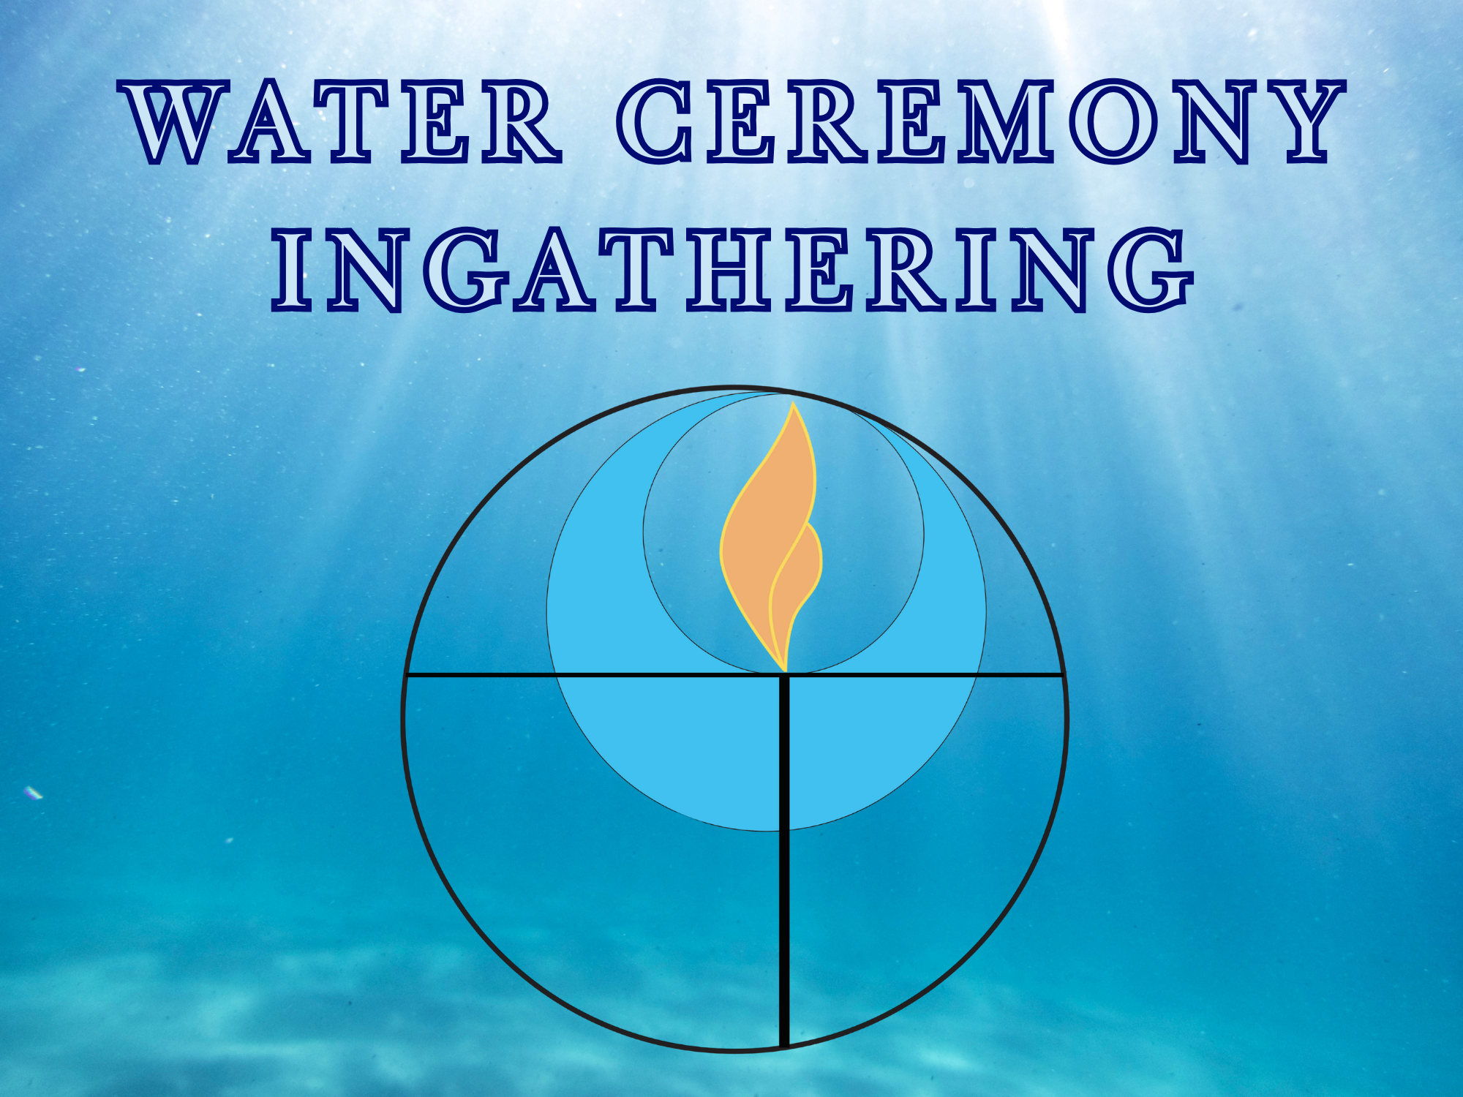

5621 Montemalaga Drive
Rancho Palos Verdes, California 90275
(310) 378-9449, wifi: PUUC-Guest, Password: PUCguest
www.pacificunitarian.org

Scan this code
To read about
PUC events and programs.

Minister: Joshua Berg (he/him)
Music Director: Dr. Severin Behnen
Religious Educator: Dr. Haven Perez
Administrator: Gaberiel Sese
Director of PSP: Sylvia Lawrence
Custodian: Jose Gurrola
A/V Tech Support: Alex Saqr
Pacific Unitarian
Universalist Church



Our Mission
We are welcoming, loving people - who come together to nurture our spirits, create community, and work for justice in the world.

Our Vision
We are becoming…

A welcoming, loving, multi-generational space that celebrates diversity and nourishes growth, transformation, and cultural expression; a place of respite, where we can respect and restore our spirits; a safe space that sparks the imagination, nurtures creativity, fosters joy, and inspires awe...

A collective of open-minded, open-hearted people who listen deeply. Inviting and inclusive, we seek wisdom within the expression of diversity today and through the ages. All students, teachers, dreamers, and doers with youthful spirits, we support the flourishing of one another’s true selves…

Cocreators of an equitable world, dynamically moving ideas into actions, we model resistance and resilience for a world that is healed and whole. A world of abundance where all can access peace, freedom, and opportunity. Where all are accountable caretakers – respecting our interconnectedness and protecting precious resources – for now and forever…

This vision is grounded in love, kindness, generosity, trust, and our collective UU values.

Our UU Values
Love the center of Interdependence, Pluralism, Justice, Transformation, Generosity, and Equity.



Centering Hymn #123, “Spirit of Life”

Reflection “Reflection on Ingathering”
Pastor Joshua

Offertory Melissa Tyrrell
We are grateful for your continued gifts to PUC. If you would like to give online today, you can scan the QR code to give with Zelle or PayPal.

Musical Offertory “I Shall Not Be Moved”
African American Spiritual/Folk Song
Spirit of Life Choir

Affirmation of Gratitude Melissa Tyrrell

Extinguishing the Chalice Melissa Tyrrell & Pastor Joshua

Postlude** Dr. Severin Behnen

**Please remain for the postlude. If you must leave, please leave before it begins.
Lunch following service is free for new visitors and a suggested $5 donation for all others. Nobody will be turned away for lack of funds and we welcome larger donations to support the ministry.

Prelude “Coming Home”
Spirit of Life Choir

Welcome & Announcements Melissa Tyrrell (she/her)
Worship Associate

Chalice Lighting Melissa Tyrrell

Opening Hymn* “Octopus’s Garden” by The Beatles

Moment for All Ages “The Wisdom Tale:
The First Water Communion”
Jackie Geist (she/her)

Water Communion Congregation

Meditation “Like a River, We Belong”
Pastor Joshua

Singing Out the Children
Go now in peace. Go now in peace.
May the spirit of Love surround you
everywhere, everywhere you may go.

Reading PUC Mission and Vision

*The congregation is invited to rise in body or spirit.
Please silence cell phones and electronic devices.
A Hearing Assistance System and printed copies of the service are available. Please see an usher for assistance.
Sunday, September 7, 2025, at 10:30 am

